Project: Event Analysis
Ikemuefuna Uzoh

Introduction
The purpose of this project was to analyze a network capture (PCAP) file from a suspected network event using Wireshark, NetworkMiner and Snort. The user stated that the home network was connected to the Internet and used for sending and receiving emails through an Internet Service Provider (ISP). However, a major network event was suspected and a packet capture was available for analysis. The purpose of this investigation was to determine what was the activity occurring during the time of the capture, what devices and services were involved, analyze network protocols and traffic patterns, determine if malicious activity was occurring, and record any alerts generated by Snort.

The analysis was executed using Wireshark to analyze packets and network statistics, NetworkMiner to identify hosts, operating systems, services, and DNS activity, and Snort to locate and identify concerning or malicious network actions . The investigation results were utilized to reconstruct the incidents that occurred during the network session and to determine whether the observed activity was a security incident.

Overview of Capture
The capture file that was analyzed was named **3523_Lab1_Capture_File.pcap**. The Wireshark Capture File Properties states that the capture began on October 30, 2005 at 17:29:35 and ended at 17:38:00. The complete capture took about 8 minutes and 25 seconds ( 505.697 seconds ) .

The capture included a total of 2,449 packets and 811,157 bytes of network traffic. The average packet size was 331 bytes and the average throughput during the capture was approximately 12 kilobits per second. The small total capture size, in relative terms, suggests normal user activity and not a large-scale data transfer or denial-of-service activity.

The first packet analysis revealed that the primary host on the network was a machine named **KAUFMANUPSTAIRS** with an IP address of **172.16.1.35**. The local gateway was listed as **172.16.0.1** and resolved to **homeportal.gateway.2wire.net**, indicating a 2Wire residential router was deployed. Looking at the TiVo Discovery packets the operating system was identified as ** Windows XP (Windows NT 5.1.2600) **

Analysis of Network Protocol
Protocol Hierarchy statistics showed different protocols present in the capture. The majority of the packets were transmitted using TCP, accounting for about 84.9% of the captured traffic. UDP traffic was ~10% of packets. Other protocols seen were ARP, DNS, DHCP, SMB, NetBIOs, TLS, HTTP, FTP, FTP Data, mDNS, Microsoft Browser Protocol & TiVoConnect Discovery Protocol.

HTTP traffic made up the bulk of network activity, contributing around 42.5% of total bytes captured. FTP Data made up about 20.1% of total bytes and TLS traffic made up about 4.7%.
The GIF and JPEG image traffic indicates that web content was downloaded during the session.

The distribution of the protocol indicates that the involved computer is a Windows home computer, used for internet browsing, email related activities, local network discovery and file transfer operations. DNS traffic was used to resolve hostnames and internet resources and ARP traffic was used to communicate between devices on the local network.

A key observation was the presence of FTP traffic. FTP accounted for a large percentage of the captured data and shows that some file transfer activity did occur during capture. The user reported that the network was used mainly for email access so the FTP traffic was worth further investigation.

Host & Network Identification
Analysis with Wireshark and NetworkMiner revealed the primary host as
**KAUFMANUPSTAIRS** with the IP address **172.16.1.35**. It’s a 2Wire HomePortal router. The host spoke with a local gateway at **172.16.0.1**.

The network was using private IP address space 172.16.0.0/16. NetworkMiner found several internal and external hosts that communicated with the system during the capture. Internal traffic consisted of ARP broadcasts, SMB Browser Protocol traffic, NetBIOS traffic and TiVo Discovery Protocol communications.

The network topology observed was a Windows XP workstation connected to a residential 2Wire gateway providing Internet connectivity . The Windows networking protocols display other discoverable devices on the local network, but no direct evidence of active access to another local workstation was found.

The gateway handled DNS resolution and routed the Internet. DNS responses showed that the router was operating properly and responding to queries originating from the workstation.# Services Used and Internet Activity

NetworkMiner determined that a few different Internet services were contacted during the capture. We saw a lot of communication with AOL infrastructure, including hosts related to dial.internet.aol.com and other AOL services. During the capture there were multiple IP addresses within the AOL network and they contributed to a large amount of network traffic.

There was also more activity with Yahoo services. DNS records and host information indicate contact with login.yahoo.com, mail.yahoo.com, sec.yimg.com and a number of Yahoo content servers. There were also MSN services like c.msn.com and advertising related domains owned by Microsoft.

Interestingly, NetworkMiner also found communication with university resources such as faculty.business.utsa.edu and ruby1604.utsa.edu. These connections indicate that the user was in contact with educational resources during the capture period.

The presence of AOL, Yahoo, MSN, and university resources indicates typical Internet activity like browsing the web, accessing email, and getting content from the Internet. No evidence of access to known malicious domains or suspicious command-and-control infrastructure was found.

Analysis of traffic spikes
Analysis of Wireshark I/O Graph showed multiple traffic spikes during capture. The largest spike was at about 95 to 105 seconds into the session, reaching nearly 180 packets per second. Later in the capture smaller spikes were observed.

The Protocol Hierarchy and Conversation statistics show that the majority of traffic spikes were related to HTTP and FTP activity. HTTP was by far the largest percentage of bytes captured and was most likely associated with web browsing activity such as page loading, image retrieval and content download. FTP traffic also added up to a lot of the observed data volume.

The spikes are closely related to communications with external servers associated with AOL, Yahoo, MSN and university resources. Evidence suggests these spikes were caused by legitimate content retrieval, not malicious network behavior.

The traffic size was still relatively small and the destinations were legitimate services, so these spikes can best be explained by user activity rather than a network attack

Snort Analysis Notes
The packet capture was processed with Snort version 2.9.17. Several alerts were generated during analysis of Snort. The alert most commonly used was identified as:

**PROTOCOL-OTHER HTTP server response before client request**

This alert was classified as Unknown Traffic, Priority 3. Communication between the workstation and external web servers multiple times. This alert is commonly encountered when packet capture begins after a connection has been established, and server responses are captured without the client requests. This means these alerts aren’t necessarily indicative of malicious activity.

Another alert type was also seen:

**Consecutive TCP small segments over threshold**

This is a Priority 2 Potentially Bad Traffic advisory. The alerts were caused by traffic from TCP port 21, which is used for FTP communications. The alert is indicating a suspicious pattern of small TCP segments which is typical behavior of regular FTP control channel traffic and not necessarily indicating something malicious is happening.

No malware infections, exploit attempts, reconnaissance activity, unauthorized access attempts or command-and-control communications were identified. Snort did not find any signatures associated with known attacks or malicious software.

Conclusions
This investigation identified the primary host, network configuration, internet services accessed, protocol usage, traffic patterns and Snort alerts associated with the packet capture. The system under study was a Windows XP workstation called KAUFMANUPSTAIRS on a private network behind a 2Wire residential gateway.

Analysis revealed communication with AOL, Yahoo, MSN and university-related services. The majority of bytes captured were HTTP traffic and a significant portion of data transfers were FTP traffic. There were a few spikes in traffic during the session, but these were related to legitimate internet communications and content retrieval activities.

Snort alerts were triggered on HTTP session timing and FTP communication patterns. However, the alerts did not indicate any exploitation attempts or malicious behavior. There were no indications of malware, network intrusion, unauthorized access, command and control communications, or data exfiltration.

Based on the evidence from Wireshark, NetworkMiner and Snort there is nothing in the capture that suggests a malicious event took place. The observed activity most closely resembles normal user activity such as web browsing, email access, content downloads and regular internet communications.

Screenshots
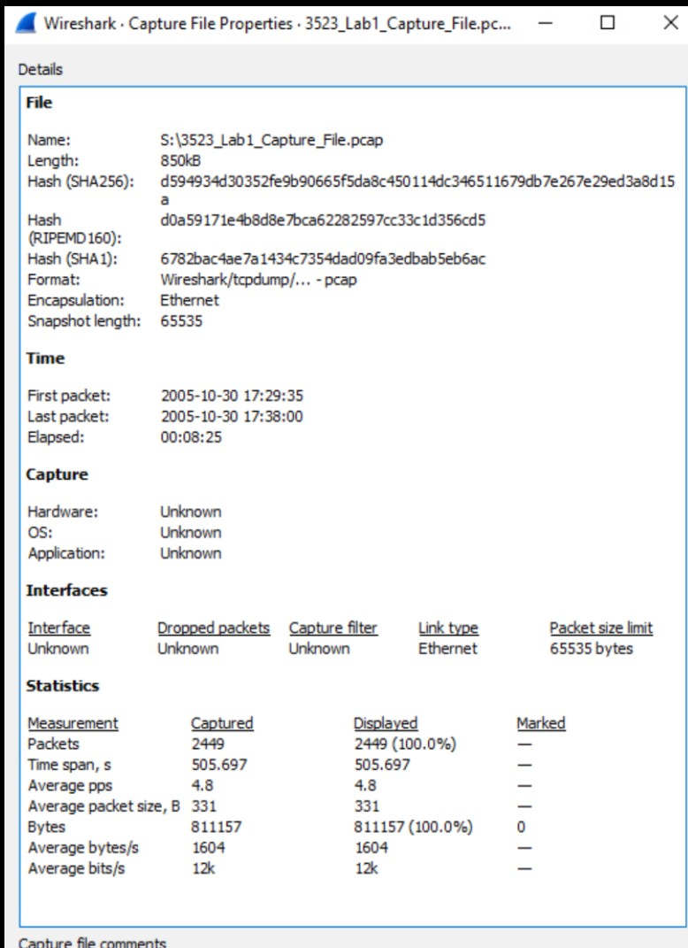

Figure 1: Capture properties

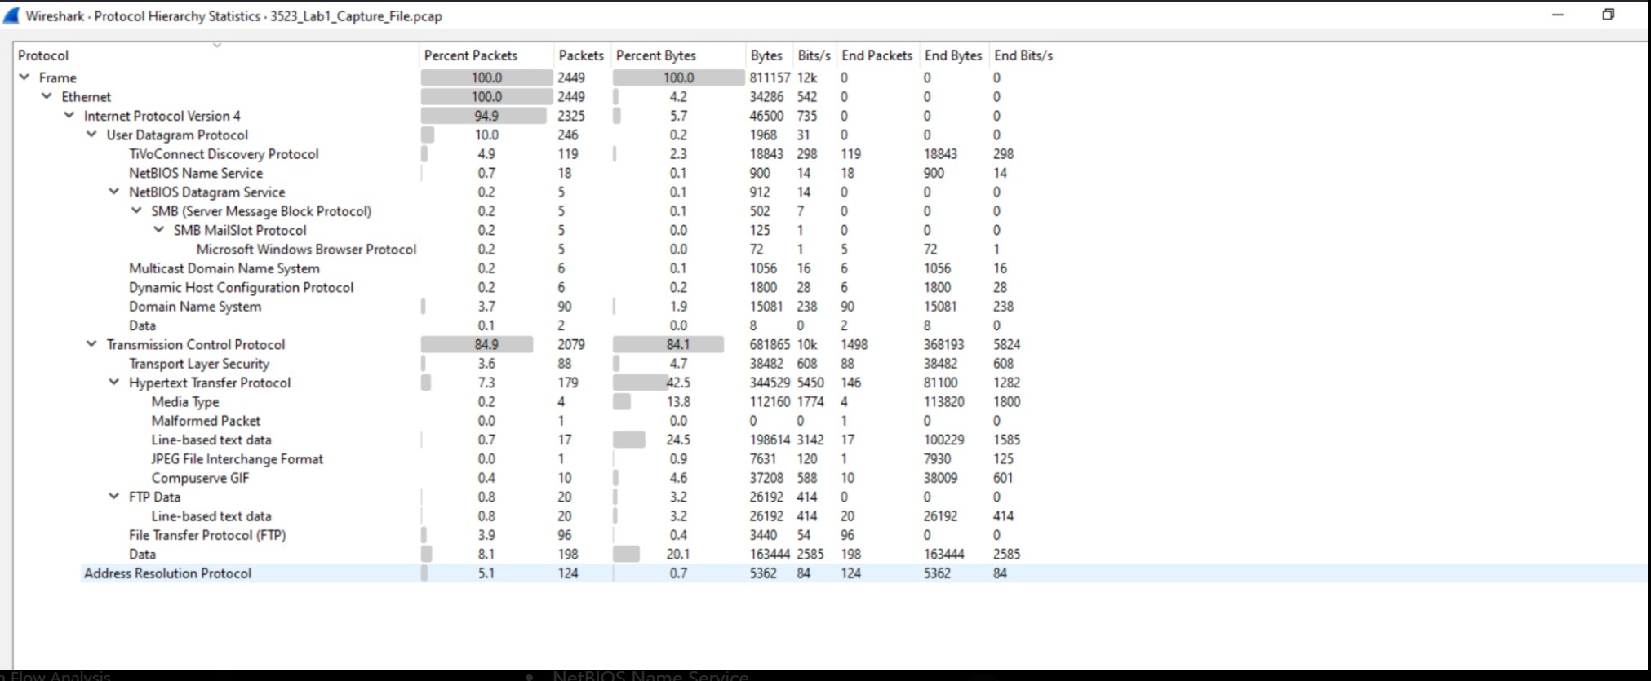

Figure 2: Protocol Hierarchy

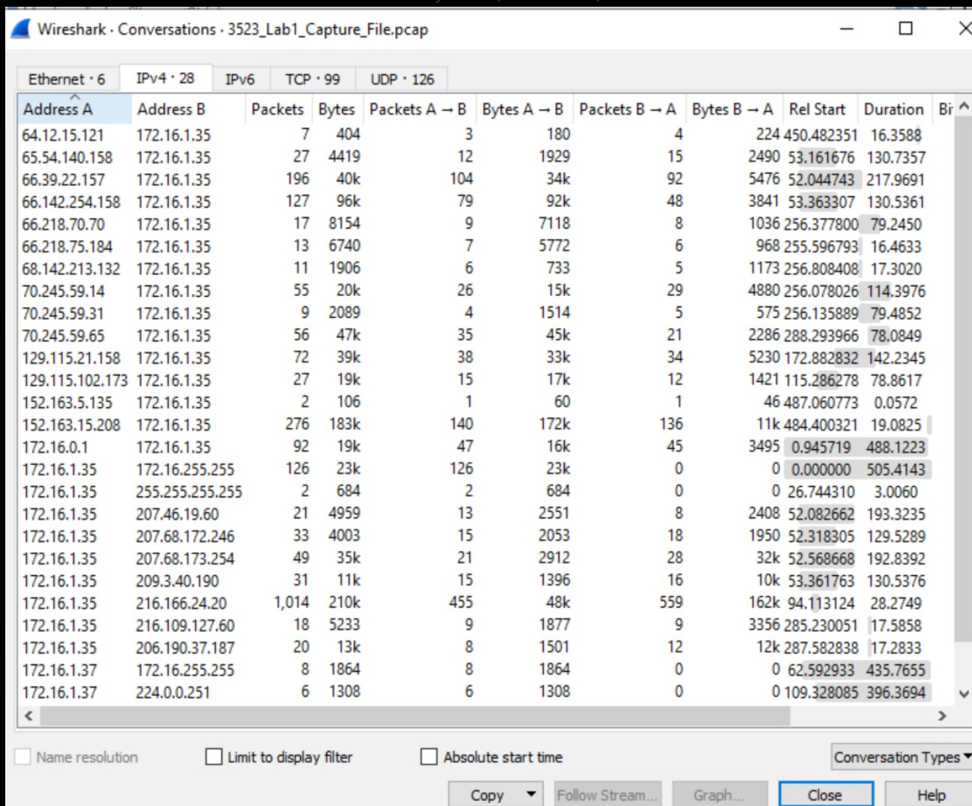

Figure 3: Conversations

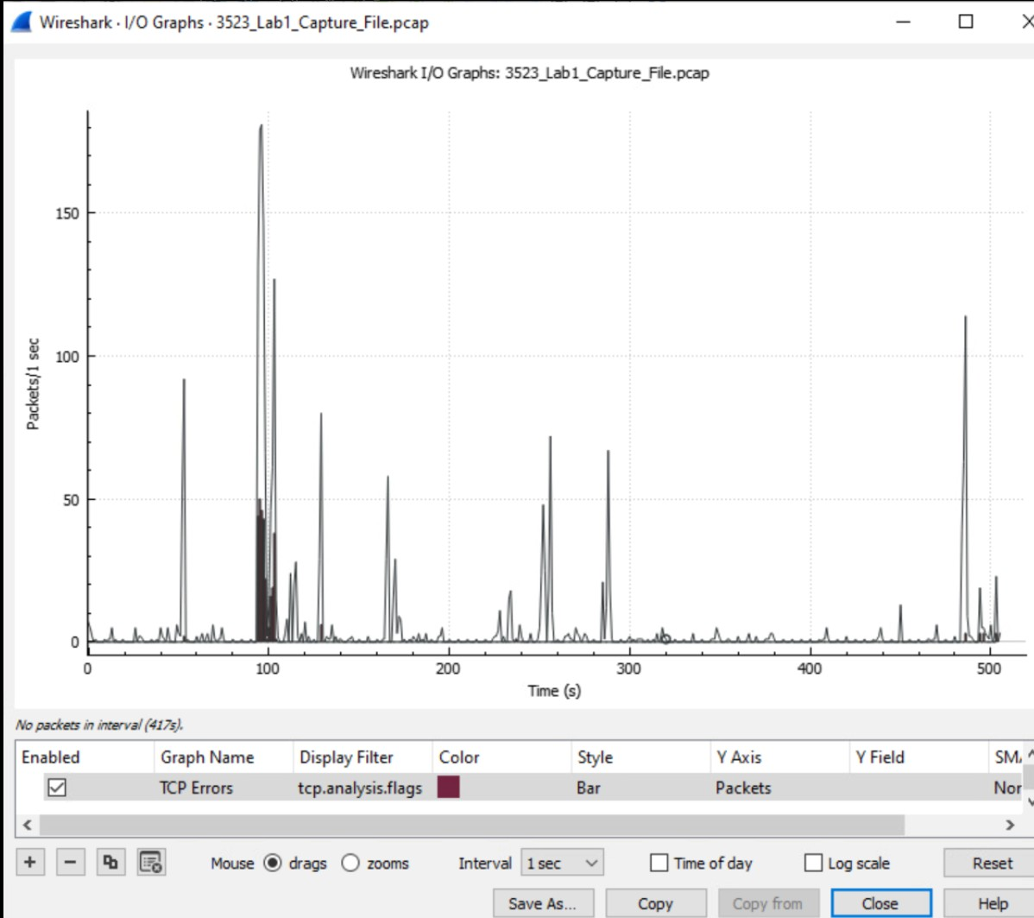

Figure 4: I/O Graph

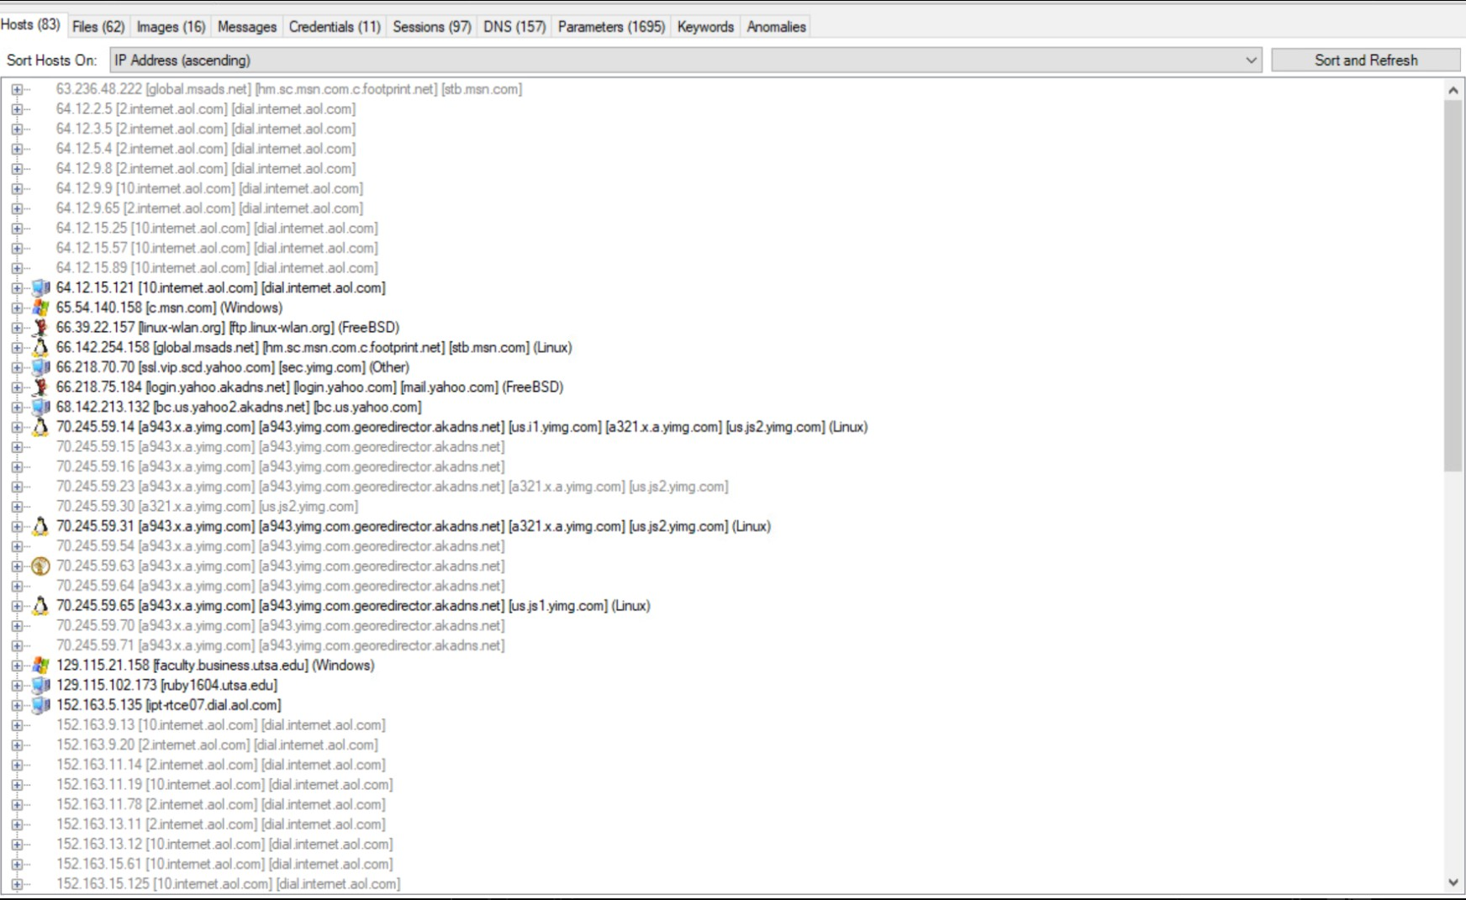

Figure 5: NetworkMiner Host

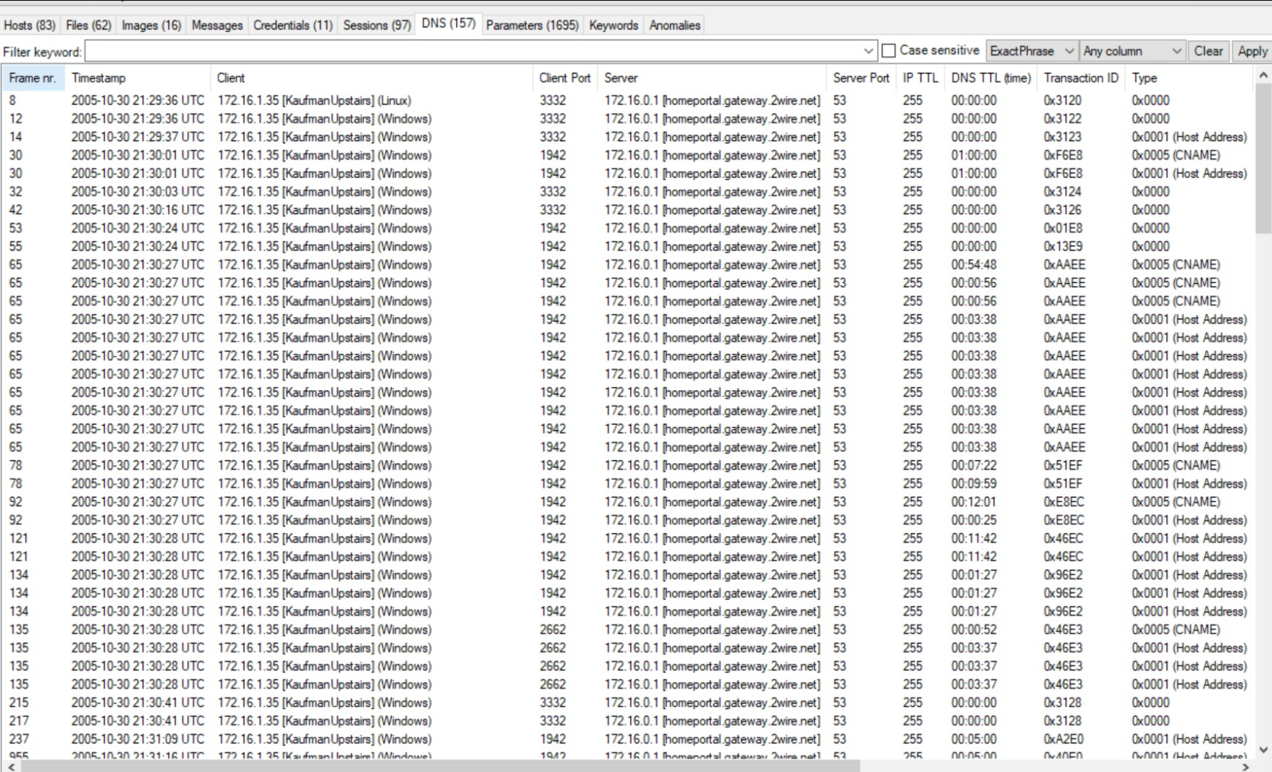

Figure 6: NetworkMiner DNS

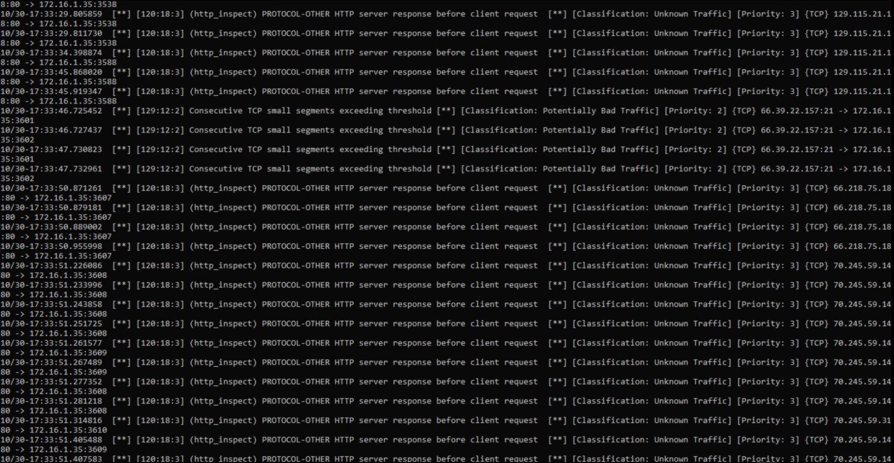

Figure 7: Snort Analysis

